 | Tell a friend |  | Share on

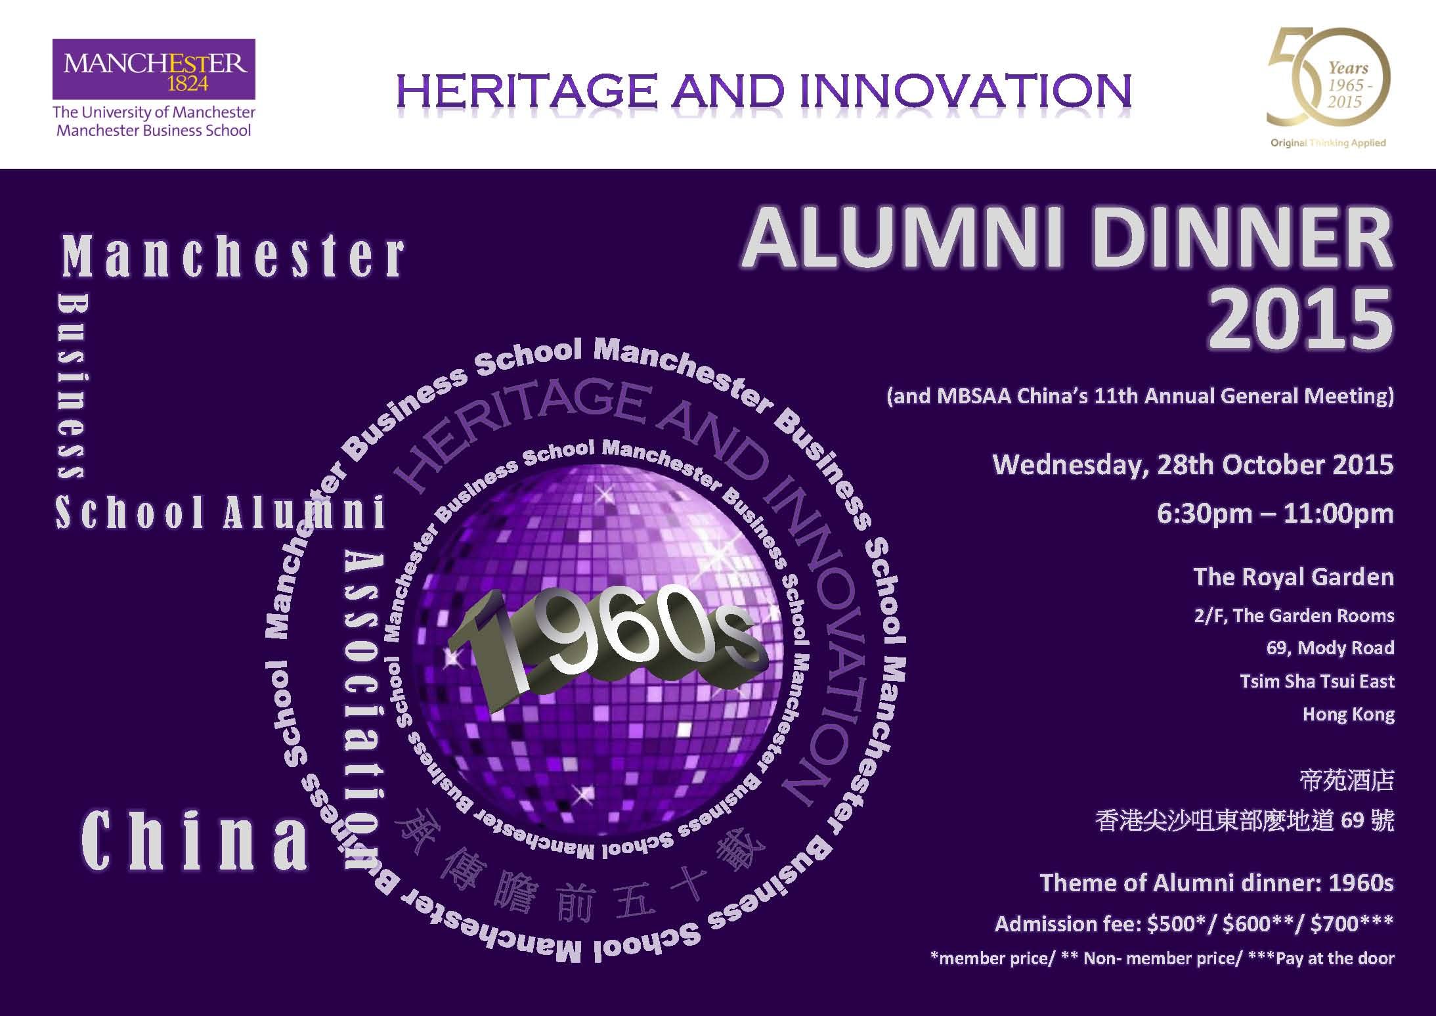
- Register Now:
- http://promo.mbs.edu.hk/content/28-october-mbs-mbsaa-china-annual-general-meeting-alumni-dinner#

The University of Manchester | Manchester Business School | East Asia Centre |
12/F Lee Gardens One l Causeway Bay l Hong Kong l
Tel +852 2588 5016 | email alumni@mbs.edu.hk | www.mbs.edu.hk

